**Bootstrap 4(W3C)**

Bootstrap 4 is the newest version of [Bootstrap](https://www.w3schools.com/bootstrap/default.asp), which is the most popular HTML, CSS, and JavaScript framework for developing responsive, mobile-first websites.

## Bootstrap 3 vs. Bootstrap 4

Bootstrap 4 is the newest version of Bootstrap; with new components, faster stylesheet and more responsiveness.

Bootstrap 4 supports the latest, stable releases of all major browsers and platforms. However, Internet Explorer 9 and down is not supported.

## Why Use Bootstrap?

Advantages of Bootstrap:

* **Easy to use:** Anybody with just basic knowledge of HTML and CSS can start using Bootstrap
* **Responsive features:** Bootstrap's responsive CSS adjusts to phones, tablets, and desktops
* **Mobile-first approach:** In Bootstrap, mobile-first styles are part of the core framework
* **Browser compatibility:** Bootstrap 4 is compatible with all modern browsers (Chrome, Firefox, Internet Explorer 10+, Edge, Safari, and Opera)

## Where to Get Bootstrap 4?

There are two ways to start using Bootstrap 4 on your own web site.

You can:

* Include Bootstrap 4 from a CDN
* Download Bootstrap 4 from getbootstrap.com

## Bootstrap 4 CDN

If you don't want to download and host Bootstrap 4 yourself, you can include it from a CDN (Content Delivery Network).

MaxCDN provides CDN support for Bootstrap's CSS and JavaScript. You must also include jQuery:

<link *rel*="stylesheet" *href*="https://maxcdn.bootstrapcdn.com/bootstrap/4.5.2/css/bootstrap.min.css">

    <script *src*="https://ajax.googleapis.com/ajax/libs/jquery/3.5.1/jquery.min.js"></script>

    <script *src*="https://cdnjs.cloudflare.com/ajax/libs/popper.js/1.16.0/umd/popper.min.js"></script>

    <script *src*="https://maxcdn.bootstrapcdn.com/bootstrap/4.5.2/js/bootstrap.min.js"></script>

**One advantage of using the Bootstrap 4 CDN:**  
Many users already have downloaded Bootstrap 4 from MaxCDN when visiting another site. As a result, it will be loaded from cache when they visit your site, which leads to faster loading time. Also, most CDN's will make sure that once a user requests a file from it, it will be served from the server closest to them, which also leads to faster loading time.  
  
**jQuery and Popper?**  
Bootstrap 4 use jQuery and Popper.js for JavaScript components (like modals, tooltips, popovers etc). However, if you just use the CSS part of Bootstrap, you don't need them.

## Create First Web Page With Bootstrap 4

**1. Add the HTML5 doctype**

Bootstrap 4 uses HTML elements and CSS properties that require the HTML5 doctype.

Always include the HTML5 doctype at the beginning of the page, along with the lang attribute and the correct character set:

<!DOCTYPE *html*>

<html *lang*="en">

  <head>

    <meta *charset*="utf-8">

  </head>

</html>

**2. Bootstrap 4 is mobile-first**

Bootstrap 4 is designed to be responsive to mobile devices. Mobile-first styles are part of the core framework.

To ensure proper rendering and touch zooming, add the following <meta> tag inside the <head> element:

<meta *name*="viewport" *content*="width=device-width, initial-scale=1">

The width=device-width part sets the width of the page to follow the screen-width of the device (which will vary depending on the device).

The initial-scale=1 part sets the initial zoom level when the page is first loaded by the browser.

**3. Containers**

Bootstrap 4 also requires a containing element to wrap site contents.

There are two container classes to choose from:

1. The .container class provides a responsive **fixed width container**
2. The .container-fluid class provides a **full width container**, spanning the entire width of the viewport



<div *class*="container">

        <h1>My First Bootstrap Page</h1>

        <p>This is some text.</p>

    </div>

.container-fluid

   <div *class*="container-fluid">

        <h1>My First Bootstrap Page</h1>

        <p>This is some text.</p>

    </div>

## Fixed Container

Use the .container class to create a responsive, fixed-width container.

Note that its width (max-width) will change on different screen sizes:

|  | **Extra small <576px** | **Small ≥576px** | **Medium ≥768px** | **Large ≥992px** | **Extra large ≥1200px** |
| --- | --- | --- | --- | --- | --- |
| max-width | 100% | 540px | 720px | 960px | 1140px |

Use the .container-fluid class to create a full width container, that will always span the entire width of the screen (width is always 100%):

## Container Padding

By default, containers have 15px left and right padding, with no top or bottom padding. Therefore, we often use **spacing utilities**, such as extra padding and margins to make them look even better. For example, .pt-3 means "add a top padding of 16px":

  <div *class*="container pt-3">

        <h1>My First Bootstrap Page</h1>

        <p>This is some text.</p>

    </div>

## Container Border and Color

Other utilities, such as borders and colors, are also often used together with containers:

<div *class*="container p-3 my-3 border">

        <h1>My First Bootstrap Page</h1>

        <p>This container has a border and some extra padding and margins.</p>

    </div>

    <div *class*="container p-3 my-3 bg-dark text-white">

        <h1>My First Bootstrap Page</h1>

        <p>This container has a dark background color and a white text, and some extra padding and margins.</p>

    </div>

    <div *class*="container p-3 my-3 bg-primary text-white">

        <h1>My First Bootstrap Page</h1>

        <p>This container has a blue background color and a white text, and some extra padding and margins.</p>

    </div>

## Responsive Containers

You can also use the .container-sm|md|lg|xl classes to create responsive containers.

The max-width of the container will change on different screen sizes/viewports:

| **Class** | **Extra small <576px** | **Small ≥576px** | **Medium ≥768px** | **Large ≥992px** | **Extra large ≥1200px** |
| --- | --- | --- | --- | --- | --- |
| .container-sm | 100% | 540px | 720px | 960px | 1140px |
| .container-md | 100% | 100% | 720px | 960px | 1140px |
| .container-lg | 100% | 100% | 100% | 960px | 1140px |
| .container-xl | 100% | 100% | 100% | 100% | 1140px |

    <div *class*="container-sm border">.container-sm</div>

    <div *class*="container-md mt-3 border">.container-md</div>

    <div *class*="container-lg mt-3 border">.container-lg</div>

    <div *class*="container-xl mt-3 border">.container-xl</div>

## Bootstrap 4 Grid System

Bootstrap's grid system is built with flexbox and allows up to 12 columns across the page.

## Grid Classes

The Bootstrap 4 grid system has five classes:

* .col- (extra small devices - screen width less than 576px)
* .col-sm- (small devices - screen width equal to or greater than 576px)
* .col-md- (medium devices - screen width equal to or greater than 768px)
* .col-lg- (large devices - screen width equal to or greater than 992px)
* .col-xl- (xlarge devices - screen width equal to or greater than 1200px)

The classes above can be combined to create more dynamic and flexible layouts.

## Basic Structure of a Bootstrap 4 Grid

*<!-- Control the column width, and how they should appear on different devices -->*

<div *class*="row">

    <div *class*="col-*-*"></div>

    <div *class*="col-*-*"></div>

  </div>

  <div *class*="row">

    <div *class*="col-*-*"></div>

    <div *class*="col-*-*"></div>

    <div *class*="col-*-*"></div>

  </div>

*<!-- Or let Bootstrap automatically handle the layout -->*

  <div *class*="row">

    <div *class*="col"></div>

    <div *class*="col"></div>

    <div *class*="col"></div>

  </div>

First example: create a row (<div class="row">). Then, add the desired number of columns (tags with appropriate .col-*-* classes). The first star (*) represents the responsiveness: sm, md, lg or xl, while the second star represents a number, which should add up to 12 for each row.

Second example: instead of adding a number to each col, let bootstrap handle the layout, to create equal width columns: two "col" elements = 50% width to each col. three cols = 33.33% width to each col. four cols = 25% width, etc. You can also use .col-sm|md|lg|xl to make the columns responsive.

## Three Equal Columns

The following example shows how to create three equal-width columns, on all devices and screen widths:

    <div *class*="row">

        <div *class*="col">.col</div>

        <div *class*="col">.col</div>

        <div *class*="col">.col</div>

    </div>

## Responsive Columns

The following example shows how to create four equal-width columns starting at tablets and scaling to extra large desktops. **On mobile phones or screens that are less than 576px wide, the columns will automatically stack on top of each other**:

    <div *class*="container-fluid">

        <div *class*="row">

            <div *class*="col-sm-3" *style*="background-color:lavender;">.col-sm-3</div>

            <div *class*="col-sm-3" *style*="background-color:lavenderblush;">.col-sm-3</div>

            <div *class*="col-sm-3" *style*="background-color:lavender;">.col-sm-3</div>

            <div *class*="col-sm-3" *style*="background-color:lavenderblush;">.col-sm-3</div>

        </div>

    </div>

## Two Unequal Responsive Columns

    <div *class*="row">

        <div *class*="col-sm-4">.col-sm-4</div>

        <div *class*="col-sm-8">.col-sm-8</div>

    </div>

Bootstrap 4 Text/Typography

[❮ Previous](https://www.w3schools.com/bootstrap4/bootstrap_grid_basic.asp)[Next ❯](https://www.w3schools.com/bootstrap4/bootstrap_colors.asp)

Bootstrap 4 uses a default font-size of **16px**, and its line-height is 1.5.

The default font-family is **"Helvetica Neue**", Helvetica, Arial, sans-serif.

In addition, all <p> elements have **margin-top: 0** and **margin-bottom: 1rem** (16px by default).

## Display Headings

Display headings are used to stand out more than normal headings (larger font-size and lighter font-weight), and there are four classes to choose from: .display-1, .display-2, .display-3, .display-4

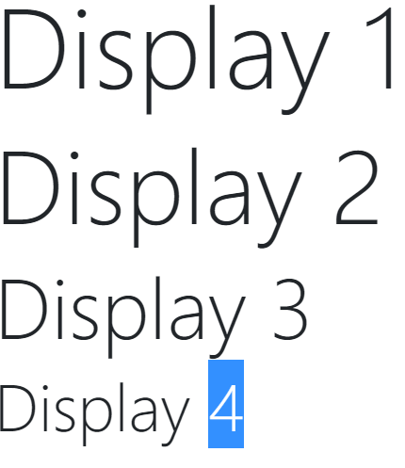

## <small>

In Bootstrap 4 the HTML <small> element is used to create a lighter, secondary text in any heading:

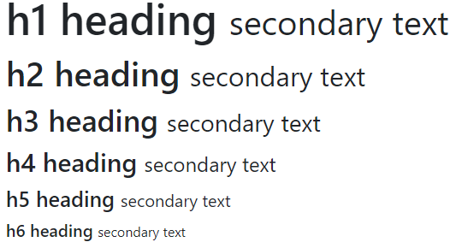

## <mark>

Bootstrap 4 will style the HTML <mark> element with a yellow background color and some padding:



## <abbr>

Bootstrap 4 will style the HTML <abbr> element with a dotted border bottom:



## <blockquote>

Add the .blockquote class to a <blockquote> when quoting blocks of content from another source:

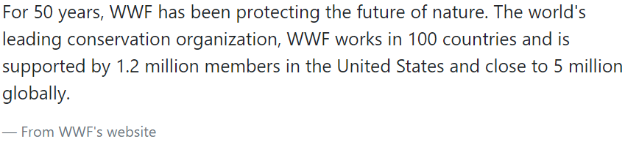

## <dl>

Bootstrap 4 will style the HTML <dl> element in the following way:

        <dl>

            <dt>Coffee</dt>

            <dd>- black hot drink</dd>

            <dt>Milk</dt>

            <dd>- white cold drink</dd>

        </dl>

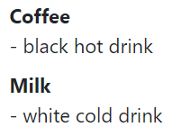

## <code>

Bootstrap 4 will style the HTML <code> element in the following way:

<p>The following HTML elements: <code>span</code>, <code>section</code>, and <code>div</code> defines a section in a document.</p>



## <kbd>

Bootstrap 4 will style the HTML <kbd> element in the following way:

     <p>Use <kbd>ctrl + p</kbd> to open the Print dialog box.</p>



## <pre>

Bootstrap 4 will style the HTML <pre> element in the following way:

        <pre>

            Text in a pre element

            is displayed in a fixed-width

            font, and it preserves

            both      spaces and

            line breaks.

        </pre>

